**Smart Search for Education - Web Application**

***Feasibility Study report***

**Objective**

*The Feasibility Study report is an analysis to know whether the project will be completed successfully with accounting factors that affect it.*

**Why is this product needed?**

*In this generation of gadgets and technology, education system has changed. Nowadays most of the education industry is focused on digitalization i.e., e-learning. Here everything depends on soft-copies and e-books. At this stage it is very painful to search for a particular topic or content as we get a lot of views and links to refer. The worst part is to search required data in scanned images and in big size documents. As in images name of image can be searched but not matter carried by it and in long docs, topic will be covered in small part but we download the whole book.*

*Hence, this product will address to problems discussed above.*

**How will the proposed system help?**

*Firstly, the scanned document will be uploaded like books, articles, notes, etc and using the Optical Character Recognition (OCR) we will extract the text content from it. Then this extracted text will be converted and send for elastic search, to make document searchable. When user search for any keyword or book or topic, the result will appear with review of document sorted according to relevance. Then user can view or download document if found useful (scanned original document). On addition they can make personal libraries from useful documents.*

**Is new technology needed? What skills? What facilities must be supported by the proposed system?**

*The requirement for the product is internet connectivity and accessible web browser on any platform. It is built for (English US) and so search will take place in same language. The problem is if the user tries to search n some other language, the product won’t work or show result. And if the product is made by the consideration that user has basic knowledge in using Web Applications.*

**What is the integration problem?**

*The application is platform independent. It can run on any web browser.*

**Is this product being affordable economically?**

*This product id developed on all open-source software/libraries which are LINUX based (UBUNTU). This is going to be free of cost as the developers will try to make it available for anyone to download and reuse under General public license V3(GNU).*

**From The Survey:**

*A survey is conducted by us which includes the user of our software i.e., teachers, students, some organizations, education institutes and people from different sectors. The results or responses are as follows:*

***1)***

**[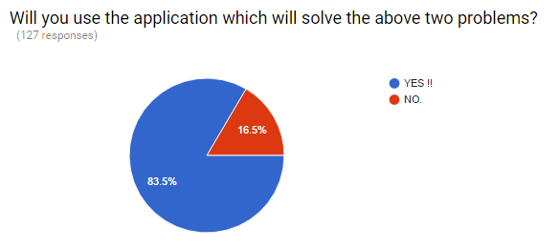](https://cloud.githubusercontent.com/assets/14366356/18721359/bcc41ef0-804d-11e6-854c-9a106620de4a.PNG)**

**2)**

**[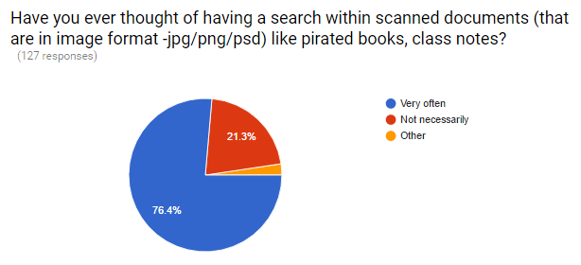](https://cloud.githubusercontent.com/assets/14366356/18721360/bd379b32-804d-11e6-8445-70f7a60c2ac9.PNG)**

**3)**

**[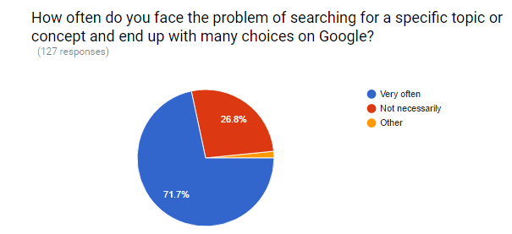](https://cloud.githubusercontent.com/assets/14366356/18721361/be2f6e02-804d-11e6-81f5-e41ca2a8e0c7.PNG)**

**CONCLUSION:**

*From the survey conducted, we concluded that 84% people are interested in the software proposed.*

*Statistically: 106 people over 127 are interested.*

*Hence this product is feasible in all aspects.*